THE [ORGANISATION NAME] HOSTS


[TYPE] RACE NIGHT

[DELETE ALL IMAGES BELOW NOT REQUIRED]
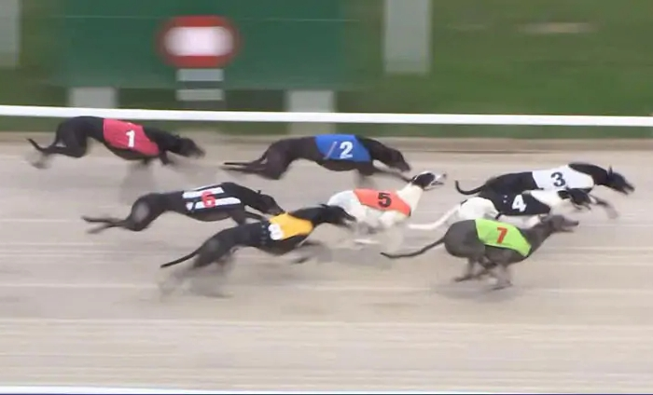

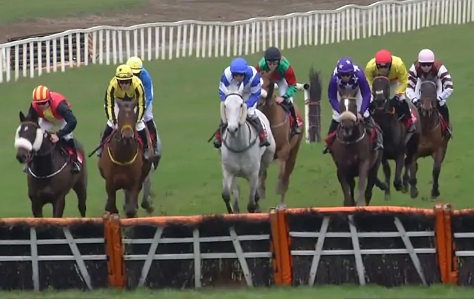

On [day, date]
In aid of [Fun Social / Fundraising for Cause]
First Race Starts at [time]
[Detail]

Sponsor a Runner for [Price] - if it wins you get a [Amount] Prize!
Or Sponsor a Race for [Price] - and get guaranteed fame!
Visit www.fundeo.com/do/ [my-event-name.html] to buy online
Contact [Name] for further details at [contact details]

